Name: Majid Ali
Lab 1 Assignment: Software Construction & Development

Course Title: Software Construction & Development (Lab)
Topic: Use Case Diagrams

------------------------------------------------------------------------------------------------------------------------------------------
Q1: Online Ticket Reservation System

Objective: Develop a use case diagram that serves as a basis for understanding the requirements for an online ticket reservation system.

Diagram Type in Visual Paradigm: Use Case Diagram

1. System Boundary:

· Draw a large rectangle and label it: Online Ticket Reservation System

2. Actors (Place outside the system boundary):

· Customer (Primary Actor)
· Payment Gateway (Secondary Actor - e.g., Bank/Credit Card System)

3. Use Cases (Place as ovals inside the system boundary):

· Search Tickets
· Select Seats
· Make Payment
· Generate E-Ticket

4. Associations (Draw solid lines connecting Actors to Use Cases):

· Connect Customer to: Search Tickets, Select Seats, and Make Payment.
· Connect Payment Gateway to: Make Pa
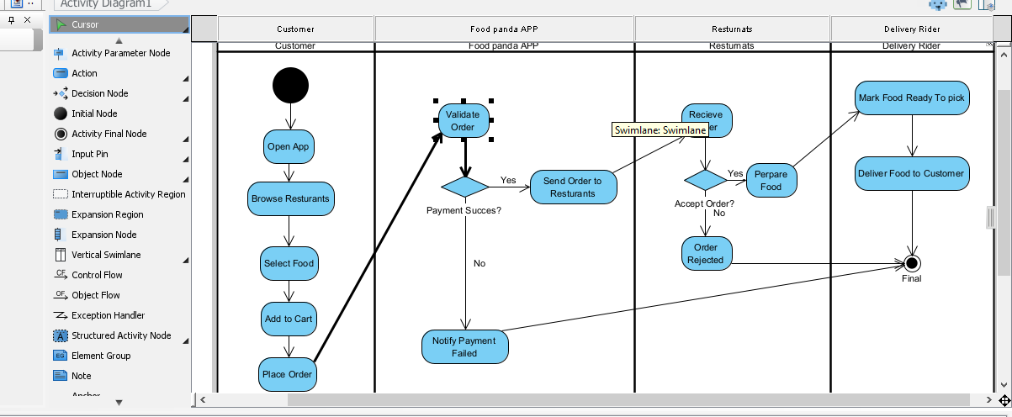
---

Q2: Credit Card Processing System

Objective: Identify actors and use cases from the provided case study and draw a use case diagram.

1. System Boundary:

· Draw a large rectangle and label it: Credit Card Processing System

2. Actors (Place outside the system boundary):

· Customer
· Vendor
· Credit Card Machine

3. Use Cases (Place as ovals inside the system boundary):

Based on the text provided in the lab manual, extract these actions:

· Select Item
· Make Bill
· Swap Card
· Process Transaction
· Issue Balance Statement
· Sign Receipt

4. Associations (Draw solid lines connecting Actors to Use Cases):

Match the text from the case study to connect the lines:

· Connect Customer to: Select Item ("Customer should select the item...")
· Connect Customer to: Swap Card ("Customer gives the credit card to the vendor to swap...")
· Connect Customer to: Sign Receipt ("Customers put the signature in the receipt...")
· Connect Vendor to: Make Bill ("Vendor makes the bill for the selected item.")
· Connect Vendor to: Issue Balance Statement ("Vendor will issue the balance statement...")
· Connect Credit Card Machine to: Process Transaction ("The required amount transaction is done by the card reader.")

---

Important Lab Instructions to Remember:

1. Do not send your assignment via Email or WhatsApp.
2. You must export your Visual Paradigm diagrams as images (PNG/JPG) and upload them to QOBE.
3. Ensure the work is entirely your own to avoid a ZERO CREDIT penalty for cheating.
